Zhijindong Cave UNESCO Global Geopark, Guizhou,China

-- Annual report on Geopark in 2018

1. Territory
Name、Country、 Regional Network：
Zhijindong Cave UNESCO Global Geopark、China、Asia-Pacific Geopark Network
Year of Membership:2015
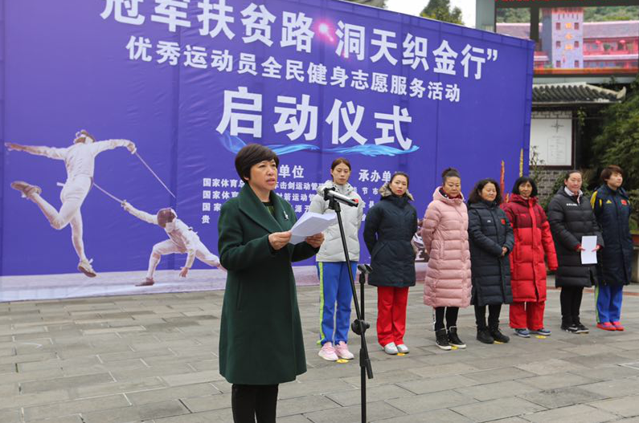

Annual Representative Events
2. Geopark Data
Quantity of employees:373 staff officers, including 2 Geological Professionals and 1 Geologist.
Quantity of Tourists: The total quantity of visitors was 4.35 million.
The Number of Geopark Activities: 6
1)We launched the geoscience popularization entering community activities in the publicity week of World Earth Day.
2)From June 29 to July 1 in 2018, We paid a visit to Danxiashan in Guangdong and Yandangshan in Zhejiang for experience learning on “Global Geopark Revalidation” and “The protection and development on Global Geopark”
3)On July 25,2018. The representatives from Zigong UGGp visited Zhijindong Cave Global Geopark for study and communication.
4) In October 2018, Representatives from Wudalianchi UGGp paid a visit to Zhijindong Cave Global Geopark for exchanging experience.
5) In October 2018, the representatives from Zhijindong attended the “Opening Ceremony of Keketuohai UGGp and the Application and Revalidation Symposium”held in Xinjiang Province.
6)On December 12,2018. The launching Ceremony of Excellent Athletes Volunteer service for national fitness entitled“Guanjun fupin Lu, Dongtian Zhijin Xing” was held in Zhijindong Cave UGGp, which is organized by the management center of cycling fencing, shooting and archery, human resources development center of the General Administration of Sports of China and Guizhou Provincial Sports Bureau, undertook by Bijie Sport Bureau、the people’s government of Zhijin County、Zhijindong Cave Administration. An taimin, the director of Zhijindong Cave UGGp, has made a welcome speech on the launching ceremony; at the same day, the investigation group from Xingwen County come to Zhijingong Cave for communication and study.
The school classes that carry out education program on Geopark:12
The number of press releases:7
3.Activities
Major achievements in 2018
1)We initiated the programming and approval work of Xiahongyan、Sanjia、Baima and Guanzhai service region in Zhijindong Cave. Till December 12, 2018, the details planning in Xiahongyan and Sanjia has been approved.
2)We’ve constructed the road located in Xiahongyan Tourism service region from Zhijindong Cave Geotourism service center to Qijiehe River in the park.
3)We’ve launched the construction of Guanzhai tourism service center in the park.
4)We’ve completed the highway construction from Da Caokou to Yingshan in Zhijindong Cave Global Geopark.
5)We’ve built a new plank road “Tian Feng” nearby the exit of Zhijindong Cave UGGp.
6)We’ve started the construction of Xiahongyan characteristic tourism town.
7)We’ve launched the sightseeing lane construction from entrance to exit.
Contribution to GGN—Attending Network Activity
- In November 11 2018, we attended the Chinese Global Geopark Annual Meeting held in Yandangshan UGGp.
2) In September 2018, we attended the 8th International Conference on Global Geopark held in Italy.
3)On August 23, 2018, we participated in the training meeting on assessment of Chinese Global Geopark organized by the Academy of Geosciences.
Management and Financial Situation:
In January-December 2018, Our Geopark has received 5.04 million visitors. The total Tourism Income reach 852 million. The park is in good management and financial condition.
Geoheritage Conservation:
1) The project of controlling rocky desertification on the surface corresponding to the Zhijindong cave body has been completed, which has ensured the effective protection of geological environment and geological heritage landscape in the cave.
2) The project of controlling the geological hazards in the Grand Canyon has been completed, and the hidden dangers of visiting the Grand Canyon Park have been eliminated.
Sustainable Tourism (Geological Tourism)
We will continue to control the access to environmental protection for industrial development, stop polluting enterprises from entering the park, give priority to the development of tourism products, expand the industrial scale and improve the industrial system, thus promoting the sustainable development of local economy. In 2018，the tourism economy continued to grow at a high speed, and all the indicators had created a new historical high,up to December 31, 4.35 million tourists were received, with a total tourism income of 852 million yuan and ticket income of 84.11 million yuan, which led to more than 11,000 local farmers out of poverty.
New education programs for the protection of geological remains, sustainable development and disaster risk reduction
1)We will continue to carry out research and application of natural disaster prevention in Zhijindong Cave Global Geopark
2) We will continue to carry out geological popularization activities in the villages around the park, such as Guanzhai, Dazhai, Xiahongyan and Huawu, in order to further enhance the awareness of resource protection among the people in the park.
3) We will continue to strengthen cooperation with Guizhou University, Guizhou Normal University, Guizhou University for Nationalities, Guizhou University of Finance and Economics, Guizhou Institute of Light Industry, Bijie Institute of Engineering Application Technology and Bijie Vocational and Technical College.
Strategic partners:
- We will continue to work with the Institute of Cave Research of the Chinese Geological Society, the Institute of Karst Geology of the Chinese Academy of Geological Sciences, the College of Resources and Environmental Engineering of Guizhou Institute of Technology, the Key Laboratory of Karst Environment and Geological Disasters of the Ministry of Land and Resources, and the College of Resources and Environmental Engineering of Guizhou University to establish an internship base for popular science education.
2) We will continue to cooperate with Guizhou Tianhong Travel Agency, Youth Travel Agency, Guizhou Zhilu Zhonggang, Guizhou Sea Travel Holiday, Shanghai Weiwan Travel Agency, Guiyang China Travel Agency, Qiandongnan National Travel Agency, Guizhou Jiaxin Century Travel Agency and other travel agencies to carry out geo-tourism.
3)We’ll continue to work with Ctrip, Meituan, Qunar, lvmama, Tongcheng network, Tuniu Network, Fliggy, xiaowoyou travel network and other media companies to establish cooperative partnership.
Promotion and marketing activities
1）We’ll continue to work with CCTV, Guizhou TV, Bijie TV, People's Network, China Daily Network, China Broadcasting Network, China Geological Network, West Development Network, Guizhou Provincial People's Government Network, Guizhou Tourism Network, Colorful Guizhou Network, Guizhou City Network, Fenghuang Network Information, Spiritual Civilization Online Network, Colorful Guizhou Impression Network, Colorful Guizhou Tourism Network, Bijie Municipal Government Network, etc. to carry out propaganda and promotion.
2) We will continue to implement various preferential and exemption policies in scenic spots of provinces, cities and counties.
4.Contact
Administrator: An Tai Min 1285278674@qq.com
Geologist: Liu Jia Ren

